# Unit 2: Do we find happiness in wealth?

## Overview

If someone asks you, “Can money buy happiness?” you probably don’t need to think about your answer. However, if someone says, “So-and-so just got a new Hummer/BMW/Audi” or “So-and-so is touring in Europe for the next month,” you might answer, “Must be nice!” We seem to be in a tug-of-war when it comes to the question of money. Do we need money to be happy? If we are living in extreme poverty, can we find happiness? Is there an optimal level of financial means to achieve the good life? This week, we will explore stories of people living under different economic conditions – impoverished farmers during the Great Depression and contemporary lottery winners - to help us consider the nature of the relationship (or if one exists) between material comfort and happiness.

## Prompts

Unit 2 is divided into 2 prompts to guide your inquiry:

Topic 1: Voices from the Dustbowl

Topic 2: Stories of lottery winners

## Learning Outcomes

Through practicing inquiry in this unit, you will:

* Examine and question definitions and assumptions about money and happiness.
* Break down inquiry from archived photos and from contemporary journalism.
* Analyze and synthesize various perspectives (from our class prompts and from classmates)
* Interpret meaning-making from a collection of archival artifacts
* Become aware of the roles of historical and contemporary experiences in answering our big question, “What is the good life?”
* Begin to examine your self-identity and your spiritual journey

## Activity Checklist

Here is a checklist of learning activities you will benefit from in completing this unit. You may find it useful for planning your work.

|  |  |
| --- | --- |
| 🗹 | **Activities** |
|  | Activity 2.1: View iconic images about the Great Depression. |
|  | Activity 2.2: Reflect in your learning journal. |
|  | Activity 2.3: Review context and background of “Voices of the Dustbowl”. |
|  | Activity 2.4: Explore the materials from the archive. |
|  | Activity 2.5: Discuss your observations and questions. |
|  | Activity 2.6: View the lottery commercials and consider the messages. Write in your learning journal. |
|  | Activity 2.7: Read the background information about the research on lottery winners. |
|  | Activity 2.8: Read the two articles about lottery winners. |
|  | Activity 2.9: Meet with your group to break down the inquiry and discuss. |

**Assessment**

Here is the assessment for Unit 2.

|  |  |
| --- | --- |
| **Group discussion**: Do we find happiness in wealth? | 2% |

## Prompt 1: Voices from the Dustbowl

Although you might acknowledge that money is not the secret key to happiness, would you willingly give up all of your finances? Would you choose poverty? Probably not. But if you do live in poverty, is it impossible for you to experience the good life? We will consider these kinds of questions through exploring historical archives from the time of the Great Depression, when all members of Western society felt the impact of the stock market crash, and, compounding this difficulty, many parts of North America entered into a time of drought and famine.

### Learning Activities

#### Activity 1: Iconic Images

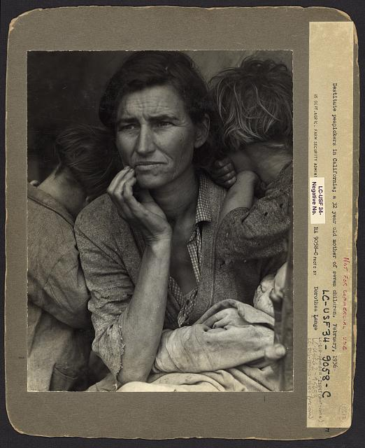

Figure 1:“Migrant Mother” by Dorothea Lange (In Farm Security Administration Collection, Library of Congress)

Look closely at the image above, “Migrant Mother.” What do you see? How does this image fit or not fit with your concept of poverty?

Look at the image below, “The American Way”. What does it show you?

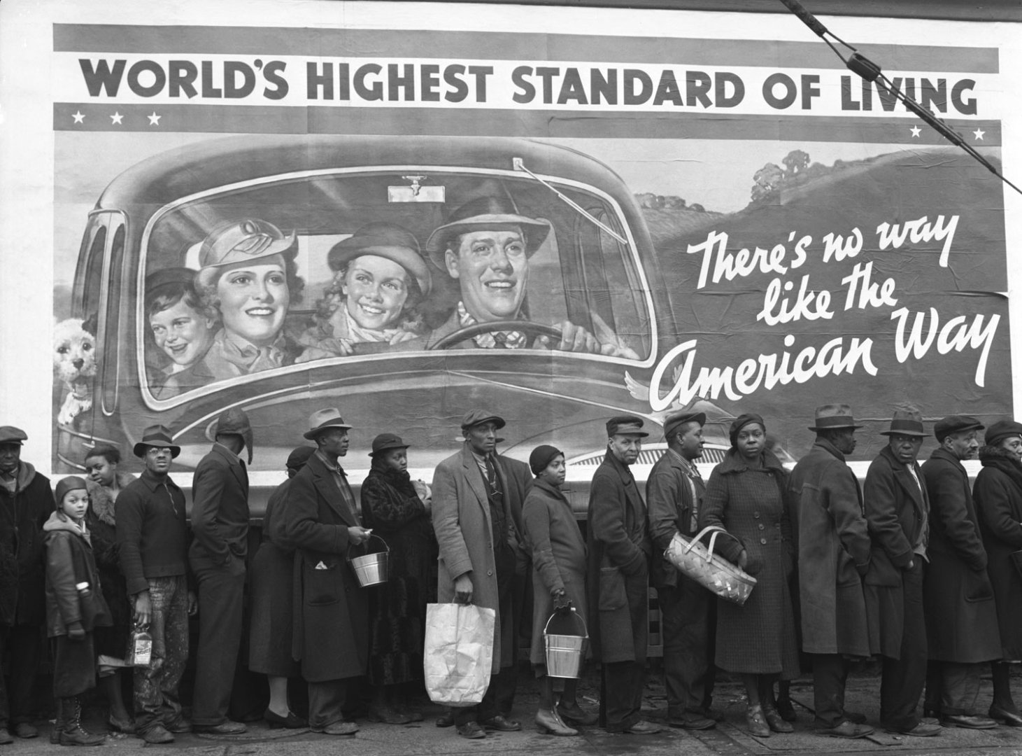

Figure 2: “[The American Way of Life](http://www.mfa.org/collections/object/the-american-way-of-life-172490)” by Margaret Bourke-White. Museum of Fine Arts, Boston. Photograph, gelatin silver print n. 1973.195

#### Activity 2: Journal Reflection

Reflect on one or more of the questions below in your journal entry. Spend approximately 5 minutes on your journal response.

* Do we find happiness in wealth?
* How do we understand wealth and poverty?
* Do you recognize these images?
* What does “iconic” mean?
* Why do you think these images have become “iconic”?

#### Activity 2.3: History of the “Dust Bowl”

Read the background on the historical and situational context of the Great Depression, the “Dust Bowl,” and the specific archival collection that we will explore.

**[put content in slide or other media for better impact]**

***The Great Depression, 1929-39 (approximately)***

The Great Depression was a time of economic disaster and widespread unemployment that impacted nations around the world. In 1929, the stock market crashed, leading to the loss of banks, businesses, and farms. In order to survive, some people became migrant workers, travelling on foot of by train to find employment, such as seasonal work. We associate terms such as “hobo” and “riding the rails” with this time in history. For a very brief overview of the economic context, see [“The Great Depression Explained in One Minute.”](https://www.youtube.com/watch?v=Sv7IP2qL0gg)

***The Dust Bowl or “The Dirty Thirties”***

In addition to the dramatic economic downturn, land that had been fertile dried up from lack of rain, and a combination of electrical currents and wind sucked the dirt up into massive dust clouds. All of the farmers suffered complete loss of crops and livestock. For a brief explanation, see this brief PBS introduction to [The Dust Bowl](https://www.youtube.com/watch?v=MYOmjQO_UMw).

***Migrant Workers***

Families were forced to flee in order to survive, loading up a few possessions and moving on to try to find better opportunities, work, food, and shelter. Many ended up living together in migrant camps, living on whatever scarce food and water they could find. For an overview, see this [short documentary](https://www.msnbc.com/today/watch/mona-lisa-of-migrant-workers-never-lost-hope-14983235628) from MSNBC (specifically the first 2 minutes).

***Farm Security Administration (FSA)***

The FSA (created in 1937) was one of the most progressive and controversial agencies at the time. The FSA advocated government planning and economic intervention to improve living conditions in rural America. Conservative critics attacked the FSA and its predecessor, the Resettlement Administration (RA), as "socialistic.” The FSA’s job was to resettle poor farmers on more productive land, promote soil conservation, provide emergency relief and loan money to help farmers buy and improve farms. In the period between 1935 and 1943, photographers with the FSA documented life in Depression-era American, producing nearly 80, 000 images.

***The Charles L. Todd and Robert Sonkin Collection (Digital Archive)***

Charles L. Todd and Robert Sonkin began the “collecting expedition” to study the way of life among migrant workers. Todd was interested in the folk culture, such as songs and stories, and Sonkin, a linguist, was interested in the use of language. Their collection is available for us to explore in a digital archive, documenting the everyday life of residents of Farm Security Administration (FSA) migrant work camps in central California in 1940 and 1941.

The whole collection includes: approximately 18 hours of audio recordings (436 titles on 122 recording discs), 28 graphic images (prints and negatives), and 1.5 linear feet of print materials including everything from administrative correspondence to news clippings.

The online presentation includes: 371 audio titles, 23 graphic images, a sampling of the dust jackets, and all the print material in the collection. We will look at a small selection from the digital archive.

#### Activity 2.4: The Collection

The following list highlights some of the most poignant pieces from The Charles L. Todd and Robert Sonkin Collection. Browse through some of the images, audio selections, and manuscripts to gain a sense of the story that these documents tell.

Photographs (and “notes” with helpful information to help you interpret the image):

* [Migrant camp, wide shot](https://www.loc.gov/item/toddbib000387/)
* [King family playing music](https://www.loc.gov/item/toddbib000391/)
* [Will Neal playing fiddle](https://www.loc.gov/item/toddbib000394/)
* [Seated woman holding baby](https://www.loc.gov/item/toddbib000396/)
* [Three men seated at table with checkerboards, spectators looking on](https://www.loc.gov/item/toddbib000405/)
* [Three men and two women seated behind a table with a microphone in front of it](https://www.loc.gov/item/toddbib000398/)
* [Woman hammering a nail into a board with spectators looking on](https://www.loc.gov/item/toddbib000403/)
* [Group of children posing under sign](https://www.loc.gov/item/toddbib000400/)
* [Group of people -- one man having his shoes shined](https://www.loc.gov/item/toddbib000404/)

**Audio Files**

The first three audio clips are spoken word and describe life in the camps. The first two are about 7 minutes each, the one about the party is just a bit more than 1 minute. The first two do talk about governance and issues of race and discrimination. The last four links are to a selection of folk songs.

[Interview about the Mexican family, discrimination against Mexicans, and life in the FSA camp](https://www.loc.gov/item/toddbib000358/)

[Interview about FSA camp governance, camp work, non-FSA migrant camps, labor issues, attitude toward "Okies”](https://www.loc.gov/item/toddbib000359/)

[Interview about a party](https://www.loc.gov/item/toddbib000345/)

[Interview about chitterlings; Disappointed in Love ; When It's Chitterlin' Cookin' Time in Cheatham County](https://www.loc.gov/item/toddbib000084/) (music)

[The Cotton Pickin’ Song](https://www.loc.gov/item/toddbib000046/)

[Untitled Cowboy Song](https://www.loc.gov/item/toddbib000080/)

[The Wabash Cannonball](https://www.loc.gov/item/toddbib000052/)

**Manuscripts**

* Music
  + [Okie Ballads](https://www.loc.gov/resource/afc1985001.afc1985001_clip001/?sp=1)
  + [Migrant Workers' Songs in California](https://www.loc.gov/resource/afc1985001.afc1985001_fn001/?st=gallery)
* [Newspaper Clippings](https://www.loc.gov/item/toddbib000365/)
* Contemporary Articles
  + [Trampling Out the Vintage: Farm Security Camps Provide the Imperial Valley Migrants with a Home and a Hope](https://www.loc.gov/resource/afc1985001.afc1985001_clip004/?sp=1)
* Correspondence
  + [1940-1941](https://www.loc.gov/resource/afc1985001.afc1985001_cor001/?sp=1)
  + [1942-1944](https://www.loc.gov/item/toddbib000368/)

#### Activity .25: Thinking about the primary sources

In your learning journal, reflect on the following questions.

* What can we know about life in California’s migrant worker camps in this period?
* What can we not know about life in California’s migrant worker camps in this period?
* What do the interviews tell us about life in the migrant worker camps? What kinds of positive experiences are described? What kind of negative experiences are described? Are they experiencing “the good life?” Explore this.
* What do the folk songs tell us about the people (or folk) who sang them? Do you notice any themes in the songs? What life perspectives do you notice? What ways of life?
* Based on this collection, do we find happiness in wealth? Do we need wealth? Does poverty equate with a lack of happiness?
* After this discussion, begin to define the good life. What is it?

As you meet with your group this week, share your thoughts about wealth and happiness in light of these questions.

*Note that as with all of the first lesson prompts, you will* ***not be graded*** *on these discussions. This prompt will help you explore the topics and will be instrumental in completing the final project.*

## Prompt 2: Research and Stories of Lottery Winners

We have looked at stories of families suffering from economic hardship. Now we will look at the experiences of people living at the other extreme: wealth. We often throw around the expression, “When I win the lottery…” with thoughts of a luxurious life and freedom from daily work. Perhaps you imagine yourself driving the car of your dreams, travelling the world, looking stunning. How does it really work out for lottery winners? Here, we will look at two journalistic pieces: an article that reports on research of lottery winners as well as an individual lottery winner’s story.

#### Activity 2.6: And the Winner Is…!

Watch the lottery commercials found at <https://www.youtube.com/watch?v=reKr-Pebo-M> and <https://www.youtube.com/watch?v=W7S38HT8EHA>

What messages do these commercials promote? Being honest with yourself, do you ever imagine yourself as a lottery winner? What would your dream life be?

Journal for approximately 5 minutes in response to the lottery commercials.

#### Activity 8: Lottery Background

In the next activity you will read two articles about lottery winners. First, read the background information to prepare for the articles.

**Journalist bios:**

* Kevin Loria is a journalist who writes for *Business Insider* and a number of other publications. He writes mostly about health, genetics, and science. Loria studied health and science journalism at CUNY Graduate School of Journalism and holds a BA in philosophy and political science from University of Notre Dame.
* Mark Gollom is a journalist for CBC working out of Toronto. He writes on politics and current social issues.

**Lottery background:**

* Powerball and other state lotteries are now in the tens of millions.
* Winning the lottery has become part of the “American dream” (and Canada’s equivalent myth of rags to riches).
* 
* Figure 2.3: "Lottery Winner Mandy Williams" flickr photo by Montage Communications https://flickr.com/photos/montagecomms/2329087866 shared under a Creative Commons (BY-SA) license

**Academic Research:**

Loria cites research from scholarly work of Blalock, Just & Simon (2007):

We examine lottery sales data from 39 states over 10 years and find a strong and positive relationship between sales and poverty rates. In contrast, we find no relationship between movie ticket sales, another inexpensive form of entertainment, and poverty rates.

He also cites Kaplan’s 1987 research on 576 lottery winners to look for behaviours and trends: 60% were male, they were older than the average, and they tended to be from higher income categories. They used their winnings to help family members and contribute to church and community. This study found that most were happy.

**Hedonic Adaptation:**

Loria cites an article by Robert Puff on the concept of “hedonic adaptation” – the idea that when we pursue and indulge in something that gives us pleasure, we eventually get tired of it and may even come to dislike it.



Image source: The Plaid Zebra: <http://www.theplaidzebra.com/overeating-one-biggest-contributors-food-waste/> **[replace photo with CC image]**

#### Activity 9: Read About Lottery Winners

Read the two articles below on the topic of lottery winners.

* Loria, Kevin. “[How Winning the Lottery Affects Happiness, According to Psychology Research.](http://www.businessinsider.com/winning-powerball-lottery-happiness-2017-8)” *Business Insider*, Business Insider, 24 Aug. 2017.
* Gollom, Mark. “['The curse of the lottery': Why a multimillion-dollar jackpot winner is fighting to keep identity private](http://www.cbc.ca/news/world/jackpot-lottery-identity-secret-1.4545575)” *CBCnews*, CBC/Radio Canada, 26 Feb. 2018,

## Assessment

### Group Discussion: Do we find happiness in wealth?

After completing this unit, including the learning activities, meet with your group to share your thoughts and challenge others. The questions to lead you are on the Group Discussion Template. Fill in the template as a record of your group’s discussion. Note that the focus is on Prompt 2, but feel free to use Prompt 1 ideas in your discussion as well. Post the link to your Google Doc as a record of your group’s discussion.

## Unit 2 Summary

In this unit, you have had the opportunity to question the connections (and/or lack of) between money/material comfort and happiness. You have considered evidence from the lives of people living in poverty during the dust bowl, research on lottery winners, and the case of one lottery winner in particular. You have experienced inquiry from archives, including photos, interviews, and music, and from journalistic writing. You have also engaged in sharing and listening to one another. These diverse voices and ways of knowing should be starting to challenge or confirm your own perspective.

## Checking Your Learning

Before you move on to the next unit, check your understanding of the following:

* Can you examine and question definitions and assumptions about money and happiness?
* Can you break down inquiry from archived photos and from contemporary journalism?
* Can you analyze and synthesize various perspectives (from our class prompts and from classmates)?
* Can you interpret meaning-making from a collection of archival artifacts?
* Have you become aware of the roles of historical and contemporary experiences in answering our big question, “What is the good life?”
* Have you begun to examine your self-identity and your spiritual journey?